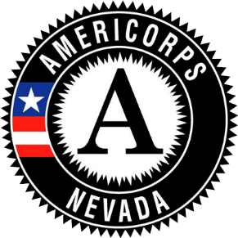

COVID-19 Grantee Request for Program Variance
COVID-19 may create situations in which normal program activities or site assignments are interrupted. CNCS COVID-19 FAQ allow for programs to develop member activities that were not originally envisioned in the approved grant activities. For members to receive service credit for activities outside of those approved in the grant award, written permission must be obtained from CNCS. This form is the application for that permission. Please note that Members and staff may not engage in any activity normally prohibited in AmeriCorps programing. While approved new activities may start immediately, programs should expect to take subsequent steps to amend their grant.

Date Request Made | March 25, 2020
CNCS Grantee ID
Legal Applicant Name
Program Name
Reassignment Description | Describe the planned changes to member activities.
Time Period | 3/2/2020 – 8/31/2020
Members Involved in Reassignment | Will all members be reassigned? Are any members continuing regular program activities?
Program Representative Submitting Request

